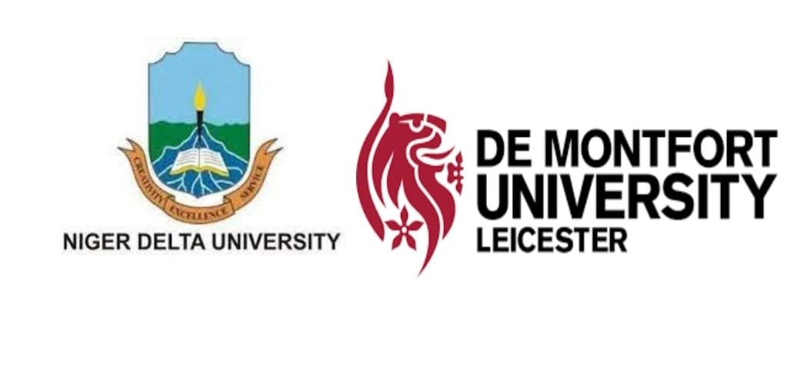
Call for Papers
Niger Delta University, Nigeria in Collaboration with De Montfort University, UK
Invites participants to a workshop titled
Making Sense of Africa’s Corporate Social Responsibility and Sustainability Transformation and its Many Futures.

Mode of Participation
Physical Location: Niger Delta University, Main Campus Auditorium, Wilberforce Island, Bayelsa State, Nigeria
Online: Details will be sent to registered participants nearer the time
Registration: https://www.eventbrite.co.uk/preview?eid=274159517497/
DATE: January 17th -18th 2023. Arrival date is 16th January 2023
Workshop Information
This hybrid workshop aims to bring together leading academics, researchers, Non-Governmental Organizations, practitioners to exchange and share experiences and research outcomes on corporate social responsibility and sustainability in Nigeria. It will also provide the desired platform for participants to present and discuss recent innovations, trends, concerns, practical challenges and solutions on corporate social responsibility and sustainability in Africa.
The workshop is centred on developments in corporate social responsibility and the move towards a more sustainable society.
Contributions in the form of full-length papers are welcome from the following thematic areas:
Theme 1
Historical and current trends of oil exploration in Africa
A notable presence of Africa in the global economy is oil production. The Niger-Delta region of Nigeria for example is home to crude oil and gas exploration which has benefited the Nigerian economy over the years. However, the region can be described as being at war with itself due to historical and political factors. This theme will address theoretical and historical issues around oil exploration and degradation in Africa. Papers will include:
- Colonialism, imperialism and the roots of conflict in African oil producing states
- Socio-political unrest, environmental degradation and oil-induced disharmonies across Africa.
- Political and economic impact of oil exploration: Resource control and allocation, poverty and economic development (agriculture and agri-business)
Theme 2
Corporate social responsibility and environmental degradation of oil production companies in Africa
This theme will look at corporate social responsibility measures of multinational companies operating across Africa in order to uncover areas of environmental degradation. Current CSR practices of oil corporations will be explored to identify areas of digression between oil companies and vulnerable communities. The legal and ethical framework across oil producing economies in Africa will be investigated to understand issues with the current regime and the impact of oil degradation on the economy. Possible areas include
- Legal and Ethical Regulation of Corporate Social Responsibility across Africa
- Corporate accountability and sustainability of multi-national oil companies
- Corruption, ethnic relations and socio-cultural dimensions of corporate social responsibility in vulnerable communities of oil-producing states
- Climate change, Corporate social responsibility and sustainable development in oil producing states.

Theme 3
Towards Corporate Sustainability of oil and other natural resource producing companies in Africa
This theme will address the future of corporate sustainability in Africa in order to identify the way forward for Africa’s corporate sustainability regime. The theme explores the emerging transition of Africa from CSR to corporate sustainability regime that aligns the process and outcomes of corporations to the needs and expectations of society. The shift from mere regulatory compliance and doing ‘something extra’ for the society into putting the society at the heart of the corporations will require multi-level stakeholder engagement that will enable corporations to begin to embed sustainability practices into their business strategies that can improve the overall financial performance of the organisation.
- Developing a corporate sustainability regime for oil production in Africa
- The Role of Stakeholders (Government, NGOs) in implementing corporate sustainability across Africa.
- Opportunities and challenges of implementing corporate sustainability in Africa.
- The future of oil and other natural resource exploration in Africa: Opportunities and challenges
The deadline for the submission of papers is not later than 23rd December 2022.
The workshop is supported by the Global Challenges Research Fund Networking Grants
Submissions should be sent to marian.chijoke-mgbame@dmu.ac.uk with the subject NDUworkshop submission
Further enquiries can be sent to Dr Marian Chijoke-Mgbame ( marian.chijoke-mgbame@dmu.ac.uk ), Dr Simi Akintoye ( simi.akintoye@dmu.ac.uk ) or Dr Michael Baghebo ( michaelbaghebo@ndu.edu.ng )

